The Ins and Outs of Team Rochester
Zvi Mowshowitz
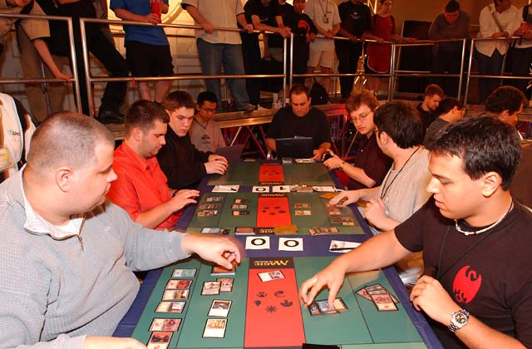
Team Rochester is by far the most skill-testing Limited format (although I still love Block Constructed) and the vast majority of teams had absolutely no idea how it worked on a strategic level. Even in sealed deck, teams were making a ton of mistakes in deck construction. Me, Alex Shvartsman and Justin Gary were far from perfect, but we definitely felt we had a substantial edge on all but a few select teams. We weren't doing everything right, but we were doing everything solidly. This isn't really the fault of the other teams. Many of them randomly qualified at a PTQ or on rating, and would have been very unlikely to make it to an individual Pro Tour. In all but a few select locations, it was impossible to find good opponents to playtest against. Many of the teams weren't local and therefore couldn't even practice together at all. That's probably a large part of why New York itself did so well this weekend - anyone could go down to Neutral Ground most nights and get a Team Sealed or Team Draft going. CMU players have had great success in Pittsburgh for the same reason. We didn't do as many sealed decks as we probably should have, but felt that compared with draft it was relatively straightforward and we were operating well enough at Grand Prix-Columbus so we concentrated on drafting.
The method I used for practicing was to get into a ton of one-on-one Team Rochesters with whoever felt well enough at home in the format and rich enough in packs to take me on. The hard part is often just convincing someone to bust open nine packs for one draft, but I have tons of packs and would have been more than willing to buy more for such a good cause. In addition, I started doing Team Rochesters online as well. Netdraft didn't have the right infrastructure for one before, but now we could load up three copies each, fix seating and start drafting. My crack team of AA, BB and CC would take on the Scott Johns All-Stars of A, B and C every day around 1:30 pm. The drafts took about three hours to do and play out, and afterwards he'd go work on Mindripper and I'd go looking for a second match. We also talked a ton about the format every day, and Scott in turn would talk to Mike Turian, the master of Team Rochester.

After two weeks of this, a solid strategy emerged. I kept winning when we played it out, although several times it seemed like I had just gotten exceedingly lucky in multiple matches, and generally at opening packs as well. It's a running joke that when I test against Scott I always seem to have all the luck. More important was to find out who should have the edge and why, and we talked about all the matchups and any picks we thought were interesting or that the other player disagreed with. After the first draft following the first consultation with Turian, we had a definite starting point straight from CMU. The player on the right (hereafter the 'A' player) would draft heavy white in addition to red and black, normally with red as the second main color and black as a splash. That would be written as W-R-b, with capital letters representing main colors in order of importance and lower case letters indicating splashes.
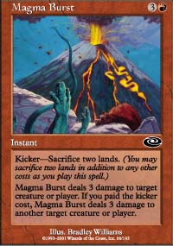
The first draft he tried this, I knew that CMU was liking the strategy but I didn't know he was going to do it. In addition, I was playing the part of the "conventional wisdom" draft strategy. Whenever we drafted we tried to assign one of the two players to draft the conventional wisdom strategy, which we abbreviated as CW. We expected the majority of teams to be drafting CW or a minor variant of it, and I believe we were correct. The default strategy was based on most people's first instincts for how to take best advantage of the cards. Planeshift has such fine cards as Terminate, Magma Burst and Flametongue Kavu and is drafted counter-clockwise. That makes it natural to put a black-red player into the A seat to ensure he can take all those cards. Given how this format works right now he would then normally end up splashing a third color. Most of the time, either it would be a touch of white for an Acolyte or two or blue for cards like Cavern Harpy or Jilt, and sometimes it would be green for Consume Strength and a guy or two. This player would go heavily into both black and red and draft something else only when forced.
On the flip side of that logic was the lefthand (or 'C') seat. He's the last chance to take Invasion and Apocalypse cards away from the other team and has the widest selection of cards to pick from. The natural instinct therefore is to put him into five-color green. As a five-color mage, he can take any card any teammate can't handle and make use of it. His counterdrafts will be productive. With those two out of the way, the natural third deck is blue-white so that goes in the center (or 'B') seat. That covers all five colors with three good decks that don't seem to fight much over cards. Then the A and B players splash colors to take the cards that would be good in their matchups or otherwise slip through the cracks. The B player will normally look to go into red if he doesn't get sucked into black early on, since that makes for the best card pool in Apocalypse. It also gives access to Slingshot Goblin, which is obviously excellent in the mirror. If both players draft this way, all three matchups are between very similar decks.

All three of us based our strategies around drafting white and red in seat A.
This setup clearly has some big advantages. It makes it quite likely any given card can be drafted profitably. It makes counterdrafting easier. It's also flexible, since one deck intends to go five colors but doesn't have to and the others have a third color they can adjust to the cards that get opened. A team that drafted this way and did it reasonably well would have been ahead of most of the competition, although they would have lost to the top teams. This format is good enough to say things like that: If a team goes in with an inferior philosophy, they are highly unlikely to win the match. The conventional wisdom can be beaten. That's what we found, that's what Car Acrobatic Team found, and that's what Phoenix Foundation found, although they developed their strategy separately and it was slightly different. All three of us based our strategies around drafting white and red in seat A.
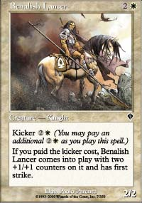
The first draft that Scott Johns tried this against me, he was kicking off. That means he gets picks for B and C, then I get a pick each for all three, then his A player gets two cards. I managed to strip the first pack of black and red cards worth playing before it got to A, and then he wheeled Benalish Lancer and Crusading Knight. Holy heavy white, Batman! When I was dividing the pack, I thought of both Lancer and Crusading Knight as double white cards. The Lancer only costs if it isn't kicked, but for it to be worth playing, the deck needs to be able to kick it. I noticed the possibility that he would get those two cards, but I assumed that would wreck his draft. He would be forced to play a lot of white and a lot of plains, and that would put him out of position. Of course, that's exactly what he wanted! In addition, he got Crusading Knight, which is obviously a monster against a red-black deck. I even had it in the back of my mind for a little while that he might well abandon the two cards, even though I had been given the heads up about the W-R-b deck earlier from another source, but it soon became clear that he was drafting it on purpose. He won that match on the strength of the Crusading Knight, and the picture started to form. I think in our testing, when the deck got the color balance it wanted against a deck that was base R-B, it lost a total of once.
Black-red on the right is also the basic assumption that can be made about the opposing team. Against everyone but the very top teams, it's fair to assume that their A deck will be black-red even before he gets any cards. That allows tricks like what I pulled that draft, and the flip side of that is that it's very possible to get the opponent to pull that trick, sacrificing cards to walk into a trap. The heavy white deck will almost always win that mirror matchup. The best part is that as a W-R-b mage, he can take full advantage of a whole bunch of Apocalypse cards that would otherwise go to waste. The big ones are Dega Disciple, Orim's Thunder, Squee's Embrace, Manacles of Decay and Goblin Legionnaire. Those are all commons! Often that deck will take an Urborg Uprising or Dead Ringers or Coalition Honor Guard and the opponents will have to choose which white-red cards to pass back for free and which to defensively (D) draft. They're also very good in the matchup, although they're pretty much good in every matchup.
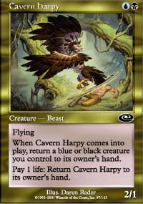
That leaves the puzzle of what to do with the other two decks. For a while, CMU reported that their W-R-b deck was winning but the other two seats were having trouble. The big question was what to do with the green deck. The blue deck was relatively easy, either drafting U-W-r or U-B-x (x means unknown additional color). The problem was that the last deck has to be green and it wasn't doing well. The green deck needed a way to use the green cards well. At first I heard that they were doing well with G-u-b, splashing for Apocalypse cards and traditional good black and blue cards. I didn't like that strategy, because it didn't have enough flexibility. That's a good deck to draft, but it throws away too many options if the wrong packs open and lets the other team play games with the packs later on. I don't have enough space to explain fully how that works here, but basically the deck lets the opponents pass too many cards knowing you can't draft them and prevents you from pulling a lot of tricks you could otherwise pull. It's also problematic to have Cavern Harpy in the green deck, since that means drafting insufficient green to take away from the other team what needs to be confiscated.
At first we thought five-color green was a mistake. The theory there is that five-color green can take anything, so it's going to take good cards away from other members of the team. It's also going to often have something else it really wants when it needs to be counterdrafting, if it goes in the C seat. Five-color green also has the problem that the only green deck on the team is now playing all the other colors, so it becomes highly questionable whether it can draft all the green cards it needs to draft to keep them away from the opposing team. This is especially true when it gets put in the C seat. The team's only green deck will be taking away cards, taking amazing cards for himself and filing in the holes on the team, and at the same time needs to take mana fixers and all the green cards! That was the original reason why the green moved over to the B seat for us. The deck in C needs to be able to take off-color cards, and the blue deck was often going into off colors with Dream Thrush, Reef Shaman and Sea Snidd. Scott in particular takes those really highly. The blue deck also has a historically good matchup against green decks, especially if it is drafted correctly for the matchup. Alex was very good at that role.

We tried putting the green together with the red and black in seat A, and that was a disaster.
What I discovered then was how to draft the green deck to defeat its traditional white-blue opponent when we were in the B seat, which is something others were failing to do. That's very complicated and another whole article, but it comes down to drafting a lot of fat, staying heavily in green cards as much as possible, taking mana fixers really highly and counterdrafting certain key cards, especially in Apocalypse. I figured this out by trial and error. We tried putting the green together with the red and black in seat A, and that was a disaster. We tried other green decks and I wasn't happy. But when I drafted the deck like this it kept winning, and it gave the rest of my decks an advantage during the rest of the draft. Rather than taking cards away from other decks, it did the opposite. It took as many green cards as possible.
There are tons of other things that teams need to know, and I hope to be able to go into more of them. They need a solid set of signals and good communication, and they need to be comfortable in the matchups they expect to have. It's not necessary that all three players actively draft their own decks (although we did that), but it's absolutely vital that those incapable of doing so take orders. One final piece of advice here is to keep it simple. Only a few very good teams are actually good enough to switch around what their players are drafting to gain an edge on matchups, beyond choosing which colors are major and minor and which color to splash or similar concerns. Try and it will generally lead to a disaster, if it wasn't discussed in advance.
If nothing else, I definitely highly recommend the Team Rochester format, including the one-on-one variety: It'll give even the best players a puzzle far more complicated than they could solve in much more time, and Invasion block has even more going on. It has an unfortunate problem of mana screw, but playing to minimize the probability of that happening is part of what makes the format so interesting. That problem can be minimized by playing best three out of five games in the matchups. There isn't enough time for that at the Pro Tour, but in a friendly match or local tournament it can really help.

